DO IT – Front End developer

Mini project 5 – Contract table design – CSS BASICS - TABLES

SMART d.o.o, New Frontier Group

Version: 1.0

Revision date: July 26, 2016

Table of Contents

Specification of mini project 2

Requirements for this project 3

Tasks 4

Timeline 5

Tools 6

# Specification of mini project

In this mini project you will done same page as shows in miniproject5after.jpg. See miniproject5before as design looks before you made changes with CSS.

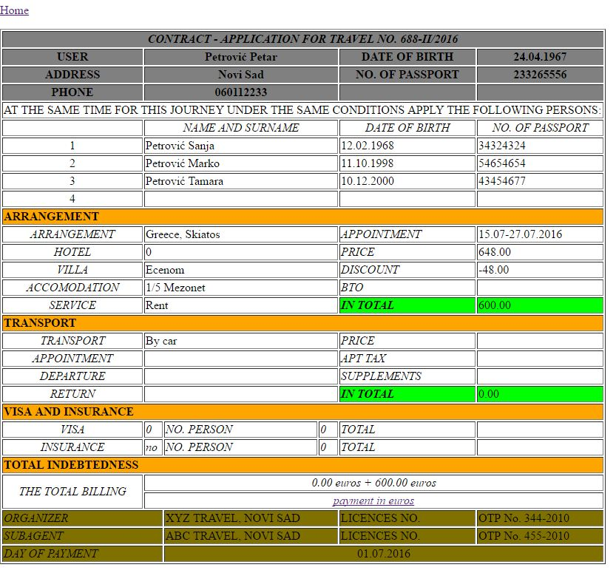

Picture 1 – miniproject5before.jpg

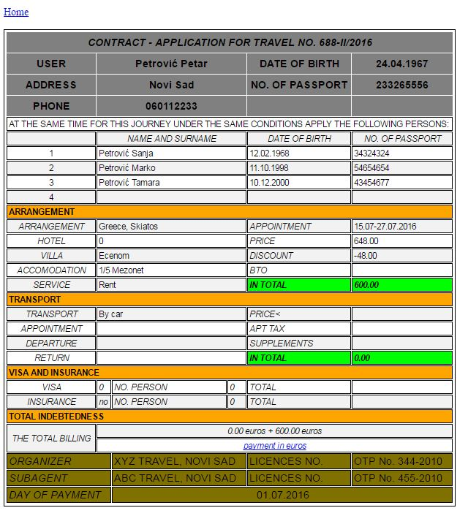

Picture 2 – miniproject5after.jpg

Your job is to make new cascade stylesheet file and make some changes in web page design using CSS basics knowledge.

# Requirements for this project

Before you can start with this project you need to finished Introduction to CSS class.

**Tasks**

So your job is to do next :

1. Use contract.html page for this project as working file, but before starting compare contract-before.html and contract.html to see difference in code, and what you will need to change. Now all design changes will be moved to CSS file table.css
2. First create CSS folder and create table.css file in this folder.
3. In contract.html call table.css as external link.
4. Now in table.css make simple selector for html and set margin and padding to 0;
5. Next simple selector for all table, row and column so that table has padding 3px, font family sans-serif and border in 1px with black line.
6. Then make changes in head of table design and change its color to #808080 ,and put size to 1em. Also make head cell 30px in height.
7. Size of body rows and columns text need to be 0.9em
8. Footer of table need to have color #807000 and also text size of 1em.
9. Id selector named home need to set home link on left side.
10. Center class selector has job to only center text that calls this selector.
11. headColor class selector need to change color to orange and to bold text.
12. Also class italicStyle need to change text to italic and put text in center.
13. Then create onlyEm class selector so that only put text in italic style
14. And finally make inTotal class selector that wil have color like #00FF00, and font style will be italic and font weight will be bold.

**Additional tasks**

1. As you table now looks different with this new design all we need to do now is to give some better look of body of our table. So now change only rows design in body of table so that has stripes( different color of even and odd rows).
2. Tip for this task will be using nth-child property of pseudo class.
3. Color of stripes need to be #f2f2f2

Your result should look like on picture miniproject5after.jpg

Good luck!

# Timeline

You will have 4 hours to finish this job.

This timeline is for main parts of the task. Bonus parts should be implemented only if there is extra time left.

# Tools

## IDE and Source Control

You can use either Atom or Brackets tool for development during this project

ATOM - <https://atom.io/>

BRACKETS - <http://brackets.io/>